**MOVIE TICKET BOOKING SYSTEM**

**Presented by**

**Soundaryalakshmi Saravanan**

**TABLE OF CONTENTS**

**Introduction** **4**

**Research** **4**

**Cost and Features and Timeline** **4**

**Features** **4**

**Defining The System** **5**

**SWOT ANALYSIS** **6**

**4W's and 1'H** **7**

**Who** **7**

**What** **7**

**When** **7**

**Where** **7**

**How** **7**

**Detail Requirements** **8**

**High Level Requirements** **8**

**Low Level Requirements** **9**

**Design** **10**

**Behavioral Diagrams** **10**

High Level Design 10

Use Case Diagram 11

**Structural Diagrams** **12**

Low Level Design 12

Level 0 12

Level 1 13

**Test Plan and Test Output** **17**

IMAGES 20

User Interface 20

User Mode 20

To Purchase Ticket 21

Ticket 1 21

Ticket 1 Summary 22

Ticket 2 23

Ticket 2 Summary 23

Ticket 3 24

Ticket 3 Summary 24

Admin Mode 25

Change Price 25

# **Introduction**

The main objective of the project is to provide information about the MOVIE TICKET BOOKING SYSTEM to a customer to book the tickets.The project has been developed to carry out the process more efficiently.The system allows the user to Book tickets,Cancel tickets,View all booking records.

# **Research**

In today's world though there are lots of platforms for entertainment movies play a major in entertaining us.Movie time is a time when the family can spend some time altogether.In order to make this hustle free Movie Ticket Booking application is developed. Movie Ticket Booking System provides the customers facility to book tickets for a movie and to gather information about the movies and theaters.Customers can book tickets of their choice and may cancel a ticket.

The main goal of the project is to provide good customer service. The application should fulfill almost all the processes required for booking a ticket.

# **Cost and Features and Timeline**

# **Features**

* Booking tickets
* Cancel tickets
* Change ticket price(only admin)

**Cost and Timeline**

* Reliability
* User Friendly
* Flexibility
* Can Select the seats as per choice

# **Defining The System**

Movie Ticket Booking System has few inbuilt features like Admin * Login * Can Change the Price of a Ticket. * Can View the Reserved Tickets. * Exit System. User * Login with Credentials. * View the Movies Available. * Purchase a Ticket. * View the available seats. * Cancel a Ticket. * Exit System.

# 

# 

# 

# 

# 

# 

# 

# 

# 

# 

# **SWOT ANALYSIS**

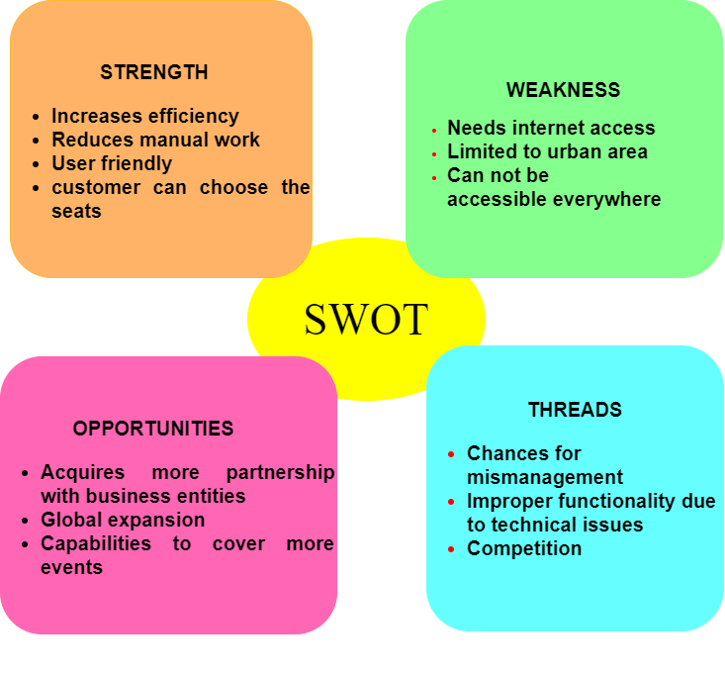

# 

# 

# 

# 

# **4W's and 1'H**

# **Who**

* This app finds applications in theaters.

# **What**

* It can be implemented to build a system to book tickets,cancel tickets,view reserved seats,and change the price of tickets(only admin).

# **When**

* To book a movie ticket when the user wants to carry out the tasks quickly and saves time.

# **Where**

* It can be implemented in theaters where there is a lot of booking,cancellation of tickets takes place manually.

# **How**

* By creating a system which will provide all the features such as booking off, canceling of the ticket.

# 

# 

# 

# **Detail Requirements**

# **High Level Requirements**

| **ID** | **DESCRIPTION** |  |  |
| --- | --- | --- | --- |
| HR01 | User should be able to login to the system |  |  |
| HR02 | User should be able to purchase a ticket |  |  |
| HR03 | User should be able to view the reserved seats |  |  |
| HR04 | User should be able to get summary of the ticket booked |  |  |
| HR05 | User should be able to cancel a ticket |  |  |

# 

# 

# 

# 

# 

# 

# **Low Level Requirements**

| **ID** | **Description** | **HLR ID** |  |
| --- | --- | --- | --- |
| LR01 | User should be able to login to the system with correct login details | HR01 |  |
| LR02 | User need to book a ticket in a user entry mode | HR01 |  |
| LR03 | If appropriate login details are not entered a message is displayed-"wrong password" | HR01 |  |
| LR04 | Displaying the movies available | HR02 |  |
| LR05 | Admin can change the price for the movie | HR02 |  |
| LR06 | If user specifies seat number which is booked ,message appears that the seat is unavailable | HR03 |  |
| LR07 | Displaying the summary of the ticket booked | HR04 |  |

# 

# **Design**

# **Behavioral Diagrams**

## **High Level Design**

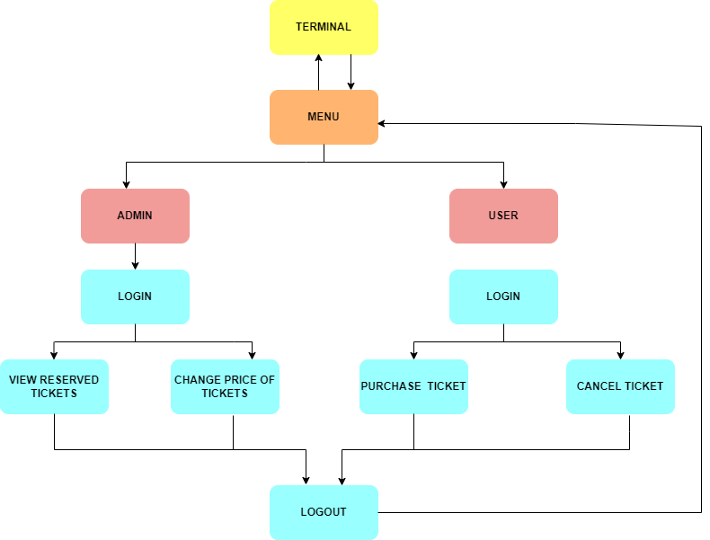

## 

## 

## 

## **Use Case Diagram**

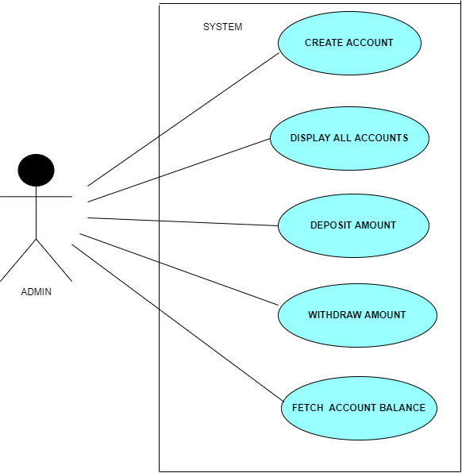

# 

# 

# 

# **Structural Diagrams**

## **Low Level Design**

## **Level 0**

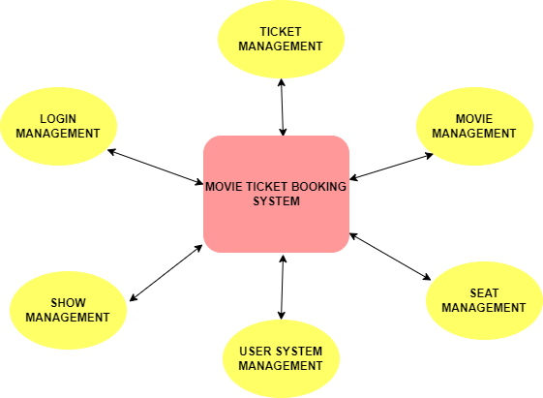

## 

## 

## 

## 

## 

## **Level 1**

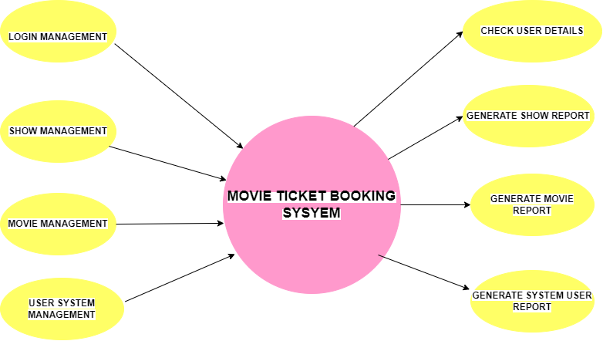

**IMPLEMENTATION**

#include<stdio.h>

#include<stdlib.h>

//#include"moviedetails.c"

#include"function.h"

#include<string.h>

#include "unity.h"

int main()

{

int count = 0;

int **seatnum,choice,price=500,selection,i;

seatnum=(int **)calloc(101,sizeof(int *));

for (i=0;i<3;i++)

*(seatnum+i)=(int *)calloc(101,sizeof(int ));

int x;

char pass[10],pak[10]="user";

while(x!=3)

{

a:choice=enterchoice();

switch(choice)

{

int y;

int ch;

case 1:

b:printf(" 1- To edit price of ticket : \n");

printf(" 2- To view reserved tickets: \n");

printf(" 3- Exit System: \n");

scanf("%d", &ch);

switch(ch){

case 1:

price=changepriceticket(price);

goto b;

break;

case 2:

details();

goto b;

break;

case 3:

y=3;

goto a;

break;

default:

printf("Choice not available\n");

break;

}

case 2:

c:

printf(" User login: \n");

printf(" 1- To purchase ticket: \n");

printf(" 2- To cancel the seat: \n");

printf(" 3- Exit System \n");

scanf("%d",&ch);

switch(ch){

case 1:

printf("Enter the password to book the ticket: ");

scanf("%s",&pass);

if (strcmp(pass,pak)==0){

selection=ListofMovies();

reserveticket(seatnum[selection-1],price,selection);

count++;

}

else

printf("Wrong Password!\n");

goto c;

break;

case 2:

printf("Enter the password to book the ticket: ");

scanf("%s",&pass);

if (strcmp(pass,pak)==0){

selection=movieselect();

cancelticket(seatnum[selection-1]);

}

else

printf("Wrong Password!\n");

goto c;

break;

case 3:

goto a;

break;

default:

printf("Choice not available\n");

break;

}

case 3:

x=3;

break;

default:

printf("Choice not available\n");

break;

}

}

}

TEST PLAN AND OUTPUT

# **Test Plan and Test Output**

| **Test ID** | **HLT ID** | **Description** | **Exp IN** | **Exp OUT** | **Actual Out** | **PASS/FAIL** |
| --- | --- | --- | --- | --- | --- | --- |
| T_01 | H_01 | Provide required details for login to book a ticket | Password | Successfully logged In | Successfully logged In | PASS |
| T_02 | H_01 | When wrong password is entered | Password | Entered Password is wrong | Entered Password is wrong | PASS |
| T_03 | H_02 | Display the details of movie available | Enter preference | Display list | Display list | PASS |
| T_04 | H_02 | Purchase a ticket for the movie available | Enter preference | ThankYou for Booking Ticket | ThankYou for Booking Ticket | PASS |
| T_05 | H_03 | Summary of a ticket for purchased movie | Enter preference | Booking ID,Customer name,Show Name,Hallno,Price | Booking ID,Customer name,Show Name,Hallno,Price | PASS |
| T_06 | H_04 | Cancel a ticket | ID number | Your ticket is canceled | Your ticket is canceled | PASS |
| T_07 | H_03 | Change the price of ticket (only admin) | Password | Please enter new amount | Please enter new amount | PASS |
| T_08 | H_03 | Change the price of ticket after login (only admin) | Enter new amount -amount | Price Updated Successfully | Price Updated Successfully | PASS |
| T_09 | H_03 | When wrong password is entered while Changing the amount of ticket (only admin) | Password | Entered Password is wrong | Entered Password is wrong | PASS |
| T_10 | H_05 | To view the reserved ticket | Password | Summary of ticket | Summary of ticket | PASS |
| T_11 | H_05 | When wrong password is entered to view the reserved ticket | Correct Password | Entered Password is wrong | Entered Password is wrong | PASS |

### **IMAGES**

### **User Interface**

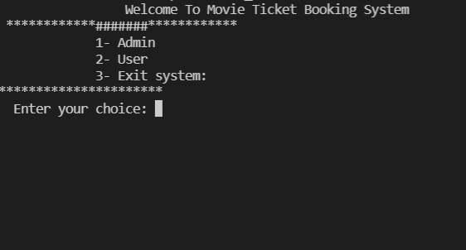

### **User Mode**

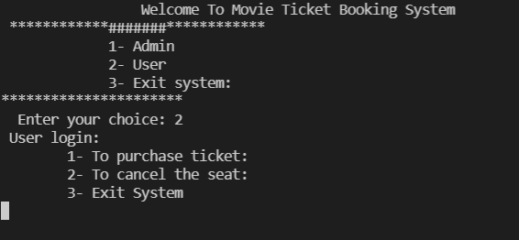

### **To Purchase Ticket**

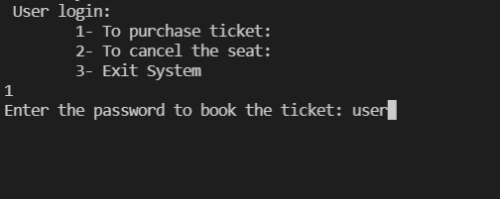 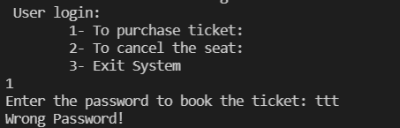

### **Ticket 1**

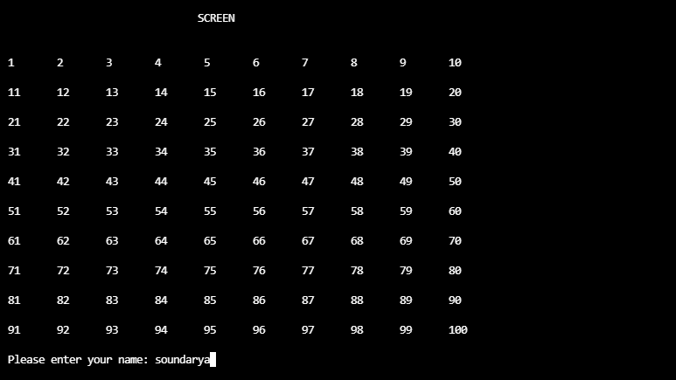 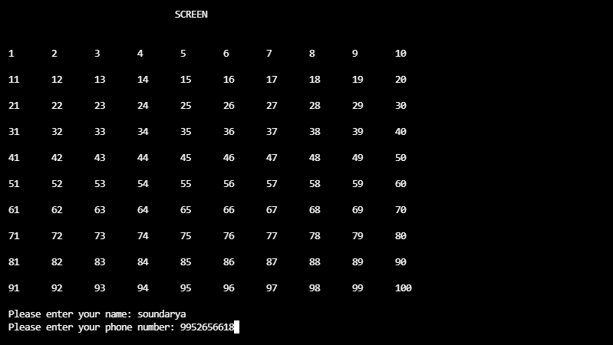

### **Ticket 1 Summary**

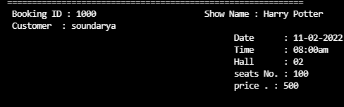

### **Ticket 2**

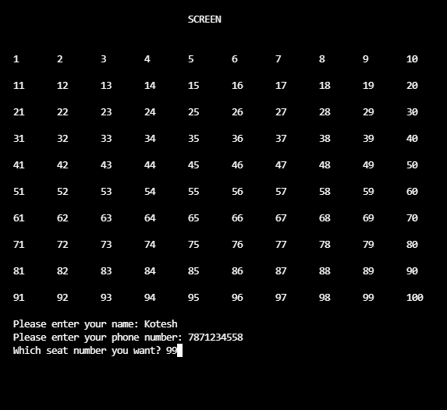

### **Ticket 2 Summary**

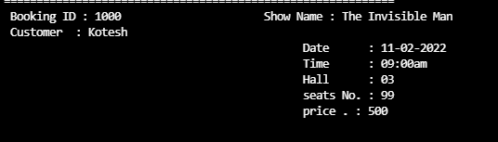

### **Ticket 3**

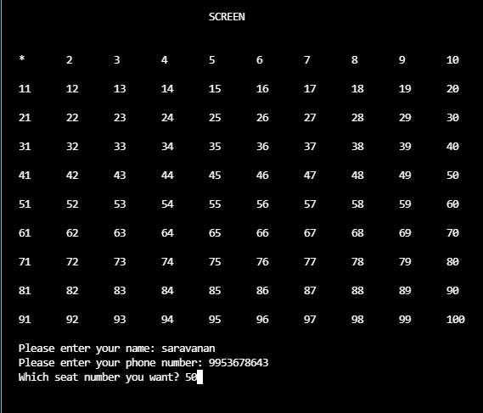

### **Ticket 3 Summary**

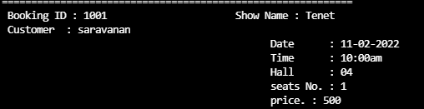

### **Admin Mode**

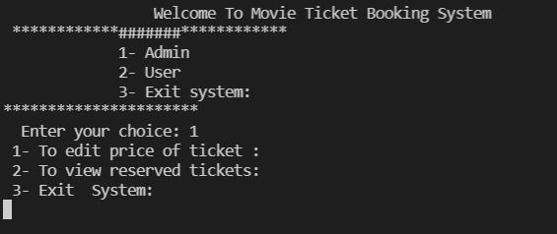

### **Change Price**

 